**A Project Report on**

**VEHICLE DETECTION AND CLASSIFICATION USING**

**INDUCTION LOOPS AND MAGNETIC SENSORS**

**Submitted by**

|  |  |
| --- | --- |
| USN | Student Name |
| 1BG10EC058 | Pradeep Kumar. N |
| 1BG10EC054 | Nikunj Tonthanahal |
| 1BG10EC047 | Nafeeya Samar |
| 1BG10EC055 | Noor Zahara |



B.N.M. Institute of Technology

Banashankari II Stage, Bangalore – 560 070

**Department of Electronics & CommunicationEngineering**

**February2014**

**TABLE OF CONTENTS**

**ACKNOWLEDGEMENT**

First and foremost, we wholeheartedly thank our project supervisor, **Prof. Anuradha V. Rao**, **Department of Electronics and Communication Engineering, BNM Institute of Technology**, for continuously encouraging us to put in our best efforts. Her suggestion to improve the project is priceless and the support lent during trying times is fully appreciated.

We are also indebted to **Prof. S. B.** **Bhanuprashanth, HOD, Department of Electronics and Communication Engineering, BNM Institute of Technology, Bangalore**, for his valuable guidance and support.

We express sincere gratitude to our project supervisors **Mr. Ravikumar, Deputy General Manager, Project and Consultancy Department** and **Mr. Surendra Kumar**, **Mr. Sourav Sarkar, Senior Engineers, Project And Consultancy Departmen**t, at **Bharat Electronics Limited, Bangalore** for assigning the project and spending their valuable time in guiding us.

Last but not the least, this project would not have been complete without the support, guidance and coordination of our parents and friends.

**ABSTRACT**

The objective of the project is to develop a traffic monitoring and classification system using low power, low cost magnetic sensors and induction loops. The data acquired from this system can be used to increase the efficiency of the existing roadways and to enhance the capacity of transportation networks at locations where the traffic densities are large.

The system can be made more effective and accurate by using auxiliary sensors such as optical, infrared, ultrasonic, triboelectric and seismic sensors. The samples from these sensors can be used when the data acquired by the primary system is ambiguous due to errors during acquisition.

**Keywords**

Traffic Monitoring, iSense core, gateway and vehicle detection modules, Induction loops, wireless sensor networks, Zigbee communication, Colpitts oscillator, Arduino 2560.

**LIST OF FIGURES**

**LIST OF TABLES**

**LIST OF SNAPSHOTS**

**CHAPTER 1**

**INTRODUCTION**

* 1. **Overview**

Maximizing the efficiency and capacity of existing transportation networks is vital because of the continued increase in traffic volume and the limited construction of new highway facilities in urban, inter-city, and rural areas. Even when additional facilities are built to ease congestion and promote the use of multiple occupancy vehicles, the cost is often quite high. An alternative to expensive new highway construction is the implementation of strategies that promote more efficient utilization of current road, rail, air, and water transportation facilities. Efficient control requires cost-efficient and accurate estimation of traffic parameters, such as the number of vehicles passing a certain point per unit time, the current speed of vehicles, and their types. The estimation can be based on data collected from magnetic sensors placed close to the road or induction loops buried into the road surface.

A vehicle is built up of several types of magnetic materials; soft magnetic materials with no residual magnetization and hard magnetic materials with high residual magnetization. All of these materials in the vehicle create a disturbance in the earth magnetic field when the vehicle passes a specific region. When we place a magnetic sensor system with a high field sensitivity and resolution in this region, it is possible to detect the vehicle. Two wheelers tend to produce a single peak in the disturbance curve due to their relatively small size. In four wheelers, the front and rear axles create relatively large disturbance in the earth magnetic field due to their proximity to the ground resulting in two peaks in the disturbance curve. The distance between the peaks can be used to distinguish between cars and heavy motor vehicles such as trucks.Thus these magnetic sensor systems can be used for classification of vehicles into different types such as motorcycles, cars and trucks. Alternately, simple induction loops can also be used where the inductance of loop changes due to the presence of vehicle. This in turn changes the frequency of oscillation of the oscillator connected to the loop which can be used as a parameter to detect the presence of a vehicle.

The data thus acquired can be used in IntelligentTransportation Systems (ITS), roadway and transit programs that have among their goals reducing travel time, easing delay and congestion, improving safety, and reducing pollutant emissions.

**1.2 Motivation**

Traffic congestion and associated effects such as air pollution pose major concerns to the public. Congestion has increased dramatically during the past 20 years in all the major Indian cities. Congestion is an outcome of twin factors, (a) growth in number of vehicles on road,

(b) limitations to expansion of road space. While the road length in urban areas was only 7 per cent of the total road length in India, in 2002, the number of registered motor vehicles in the 23 largest cities alone was 30 per cent of the total registered motor vehicles in the country. Thus, urban congestion is a serious problem and has severely constrained mobility.

Traffic congestion may be alleviated by improving the efficiency of the current transportation system through the implementation of advanced technologies. Real-time traffic surveillance is one of the most important components of such an approach, and real-time travel information is useful for advanced travel advisory systems. Emergency management agencies such as police, fire stations, and ambulance dispatchers may also benefit from real-time traffic information in routing their vehicles through the transportation network to save lives. Roadway safety and efficiency will be significantly enhanced by employing remote sensing and communication technologies capable of providing low-cost, scalable, and distributed data acquisition of road conditions. Such Intelligent Transportation System (ITS) applications require distributed acquisition of different traffic metrics such as traffic speed, volume, and density which can be obtained using magnetic sensors and induction loops.

**CHAPTER 2**

**LITERATURE SURVEY**

**2.1 General description**

This project involves various hardware components such as iSense core, gateway and vehicle detection modules, Inductive loops, Colpitt’s oscillator, Jennic and Arduino 2560 microcontrollers. The Eclipse IDE and Arduino software were used to program the Jennic microcontroller and Microsoft Visual Studio was used to develop the GUI. The project uses the concepts of embedded systems, measurements, sensors and wireless communication networks. This chapter highlights the details of each of the above topics.

**2.2 iSense Core Module**

The iSense Core Module is based on a Jennic JN5148 wireless microcontroller [4], a chip that

combines the controller and the wireless communication transceiver in a single housing.

The controller provides 32 bit RISC computation and runs at a software-scalable frequency between 4 and 32 MHz. It comprises 128kbytes of memory that are shared by program code and data. The

advantage of this choice is that memory consumption of program code and data can be traded.

Opposite to other controllers where the user is limited to a certain amount of data and code memory,

free choices that are only bounded by the sum of both become possible here.

The radio part complies with the IEEE 802.15.4 standard [5]. It achieves a data rate of 250kBit/s,

provides hardware AES encryption and is ZigBee-ready. As the world’s first IEEE 802.15.4 radio, it

supports distance measurements to neighboring devices using time of flight ranging. Besides IEEE

802.15.4 standard compliant operation, the radio transceiver provides two additional modes of

operation, offering increased data rates of 500kBit/s and 667kBit/s.

Apart from the CM30U version that is equipped with a μFL antenna connector, the CM20I with an

integrated PCB antenna for especially compact systems is available. Both provide a receive sensitivity of -95dBm (at 250kBit/s) and a transmit power tunable between -60dBm and +2.5dBm.

In addition, a Core Module version (CM30HP) with a power amplification stage for transmitting and

receiving is available. It is equipped with a μFL antenna connector, reaches a receive sensitivity of -

98dBm (at 250kBit/s) and a transmit power of up to 10dBm.

A common quandary in design is whether or not to use a voltage regulator. It has the advantage that

operation with voltages lower than the required one is possible, but the regulator inherently wastes

energy. This is especially bad as it also wastes current if the voltage would be high enough and the

regulator would not be required. To resolve this problem, we decided to combine the measurement of the supply voltage with the possibility to bypass the regulator by a software switch. Like this, the

regulator usage can be omitted when not required but is available when the supply voltage drops.

To enable long, but still synchronous sleep and wakeup cycles, the module is equipped with a high

precision clock (error < 30ppm). The Core Module also features a software-switchable LED for

debugging purposes.

**2.3 iSense Vehicle Detection Module**

The iSense Vehicle Detection Module (VDM10) is used for the detection of dynamic magnetic fields.VDM10 is based on the two-axis anisotropic magneto-resistive (AMR) sensor Phillips KMZ52. It is combined with two cascaded amplifier stages and additional control and compensation circuits. In order to offer a wide detection range of up to 5 meters, the module provides two sensitivities, i.e. the amplification factor of the second amplifier stage can be switched from low gain to high gain mode. The module also provides a degaussing circuitry and static magnetic field offset compensation. All three are controlled via I2C commands. In combination with an iSense Core Module (CM30x) connected to the VDM10, the Vehicle Detection Module can be used to detect large metal objects such as cars moving by. The accompanying software incorporates automatic degaussing as well as earth magnetic field and sensor offset compensation for convenient sensing. The C++ driver that is part of the iSense sensor networking and operating firmware provides a convenient API to operate the different hardware components of the Vehicle Detection Module. Hence, module activation degaussing, offset compensation and amplifier control are done by simple API calls.

**2.4 Inductive loops**

The principal components of an inductive-loop detector system include:

* One or more turns of insulated loop wire wound in a shallow slot sawed in the pavement.
* Lead-in cable from the curbside pull box to the intersection controller cabinet.
* Electronics unit housed in a nearby controller cabinet.

The inductive-loop system behaves as a tuned electrical circuit in which the loop wire and lead-in cable are the inductive elements. When a vehicle passes over the loop or is stopped within the loop, the vehicle induces eddy currents in the wire loops, which decrease their inductance. The decreased inductance actuates the electronics unit output relay or solid-state optically isolated output, which sends a pulse to the controller signifying the passage or presence of a vehicle.

Inductive-loop wire, lead-in wires, and lead-in cables typically use #12, #14, or #16 American Wire Gauge (AWG) wire. We have used #12 AWG wire. The loop in the roadway also contains an induced resistance (called the ground resistance) caused by transformer coupling between the loop and induced currents flowing in the roadway and subgrade materials.

A roadway inductive loop has a nonuniform flux field that produces an inductance value given by

Capital L is equal to the quotient of the product of mu subscript R, mu nought, Capital N squared, Capital A, and Capital F prime all over L.

where,

*r* = Relative permeability of material (1 for air)  
mu*0* = 4pi x 10-7 henrys per meter.



*L* = Inductance, henrys  
*N* = Number of turns  
*I* = Coil current, amperes.

*H* = Magnetic field,

*A* = Cross sectional area of coil, m2

F' = a factor to account for the non uniform flux in the roadway inductive loop

**2.5 Colpitt’s oscillator**

Oscillators are circuits that generate a continuous voltage output waveform at a required frequency with the values of the inductors, capacitors or resistors forming a frequency selective LC resonant tank circuit and feedback network. The frequency of the oscillatory voltage depends upon the value of the inductance and capacitance in the LC tank circuit. Then the frequency at which this will happen is given as:

XL = 2𝜋𝒇L and Xc= 𝟏/𝟐𝝅𝒇𝑪

**At resonance:** XL = XC

∴ 2𝜋𝒇L = 𝟏/𝟐𝝅𝒇𝑪

𝒇2 = 𝟏/𝟒𝝅 2𝑳𝑪

Therefore the resonance frequency of an LC oscillator is

**f =** 𝟏/𝟐𝝅 sqrt(𝑳𝑪) **…………………….1.5**

Where:

L is the Inductance in Henries

C is the Capacitance in Farads

fr is the Output Frequency in Hertz

This equation shows that if either L or C is decreased, the frequency increases. This output frequency is commonly given the abbreviation of ( fr) to identify it as the “resonant frequency”.

The Colpitt’s oscillator made for the project utilizes MC33274, a quad-opamp IC which oscillates at a resonant frequency of 50 KHz. The oscillator makes use of an inductive loop of 100µH and effective capacitance of 0.22µF. The output of the oscillator is fed to a comparator which produces square waves of the same frequency as the oscillations, ready to be fed to the microcontroller.

**2.6 Arduino 2560**

The Arduino board uses a High Performance, Low Power Atmel® AVR® 8-Bit Microcontroller. The ATmega 2560 is a low-power CMOS 8-bit microcontroller based on the

AVR enhanced RISC architecture. Some of the peripheral features of the Arduino include two 8-bit Timer/Counters with separate Prescaler and Compare Mode.

The microcontroller board is suitable for wide temperature ranges varying from -40°C to 85°C.

It also includes properties of Ultra-Low Power Consumption with two different modes of operation:

– Active Mode: 1MHz, 1.8V: 500μA

– Power-down Mode: 0.1μA at 1.8V

It also has High Endurance Non-volatile Memory Segments

– 256KBytes of In-System Self-Programmable Flash

– 4Kbytes EEPROM

– 8Kbytes Internal SRAM

– Write/Erase Cycles:10,000 Flash/100,000 EEPROM

– Data retention: 20 years at 85°C/ 100 years at 25°C

This microcontroller is programmed to calculate the frequency of the signal fed at one of its I/O pins. The deviation of frequency from the central frequency of the oscillator determines that a vehicle is present in the inductive loop. This helps in vehicle detection.

**CHAPTER 3**

**DESIGN**

**3.1 Introduction**

The project involves designing of the following:

1. Induction loop detector system
2. AMR sensor vehicle detection system

**3.2 Project Requirements**

The requirements of the project can be classified under two categories:

1. Hardware requirements
2. Software requirements

**3.2.1 Hardware Requirements**: The hardware requirements for each approach are listed below.

**Induction loop detector system**

* Induction loop
* Colpitt’s oscillator
* Comparator
* Microcontroller: ATmega 2560
* 9V battery
* Voltage regulators

**AMR sensor vehicle detection system**

* Anisotropic Magneto Resistive sensors
* Microcontroller with transceiver: Jennic JN5148
* 1.5V batteries

**3.2.2 Software Requirements**: Software requirements apply to both the PC as well as the microcontroller.

**Induction loop detector system**

* MCU software: Arduino
* LTspice

**AMR sensor vehicle detection system**

* Jennic compiler
* Cygwin
* Eclipse IDE
* Microsoft Visual Studio

**3.3 Design of Induction loop detector using Colpitt’s oscillator**

An oscillator has a small signal feedback amplifier with an open-loop gain equal to or slightly greater than one for oscillations to start but to continue oscillations the average loop gain must return to unity. In addition to these reactive components, an amplifying device such as an Operational Amplifier or Bipolar Transistor is required. Unlike an amplifier there is no external AC input required to cause the Oscillator to work as the DC supply energy is converted by the oscillator into AC energy at the required frequency.

A = 𝑉𝑜𝑢𝑡/𝑉𝑖𝑛

A= open loop voltage gain (i.e without feedback)

Now let a fraction 𝛽 of the output voltage 𝑉𝑜𝑢𝑡 be supplied back to the input.

𝑉𝑖𝑛 = 𝑉𝑖𝑛+𝑉𝑓 = 𝑉𝑖𝑛+𝛽𝑉𝑜𝑢𝑡 ………………………… 1.1

𝑉𝑖𝑛 = 𝑉𝑖𝑛 −𝑉𝑓 = 𝑉𝑖𝑛+𝛽𝑉𝑜𝑢𝑡 …………………………1.2

Equation 1.1 is for positive feedback while equation 1.2 is for negative feedback

Where 𝑉𝑆 is the signal voltage and 𝑉𝑓 is the feedback voltage.

That is:

𝑉𝑖𝑛 = 𝑉𝑠±𝛽𝑉𝑜𝑢𝑡

Considering negative feedback

𝐴 𝑉𝑠−𝛽𝑉𝑜𝑢𝑡 = 𝑉𝑜𝑢𝑡

𝐴. 𝑉𝑠 = 𝑉𝑜𝑢𝑡 1 + 𝐴𝛽

The term βA is called the feedback factor whereas β is known as the feedback ratio and 1+βA is known as loop gain.

(𝑉𝑜𝑢𝑡/𝑉𝑠) = (𝐴/1+𝐴𝛽) = 𝐴𝑓 …………….1.3

𝐴𝑓 = the closed loop gain

This is normally refer to as the closed loop voltage gain for negative feedback and for positive feedback

𝐴𝑓 = 𝐴/1−𝐴𝛽

LC Oscillators are circuits that generate a continuous voltage output waveform at a required frequency with the values of the inductors, capacitors or resistors forming a frequency selective LC resonant tank circuit and feedback network. This feedback network is an attenuation network which has a gain of less than one (β <1) and starts oscillations when Aβ>1 which returns to unity (Aβ=1) once oscillations commence. The LC oscillator’s frequency is controlled using a tuned or resonant inductive/capacitive (L, C) circuit with the resulting output frequency being known as the Oscillation Frequency. By making the oscillators feedback a reactive network the phase angle of the feedback will vary as a function of frequency and this is called Phase-shift.

The frequency of the oscillatory voltage depends upon the value of the inductance and capacitance in the LC tank circuit. We now know that for resonance to occur in the tank circuit, there must be a frequency point were the value of XC, the capacitive reactance is the same as the value of XL, the inductive reactance (XL XC) and which will therefore cancel out each other out leaving Only the D.C resistance in the circuit to oppose the flow of current. If we now place the curve for inductive reactance of the inductor on top of the curve for capacitive reactance of the capacitor so that both curves are on the same frequency axes, the point of intersection will give us the resonance frequency point, (fr or ωr).

An induction loop detector provides a low cost method for detection of vehicles.

The system consists of a loop of wire (typically 2 or 3 turns) buried approximately 50 mm below the road surface. The ends of the loop are returned, via a twisted pair, to the vehicle detector usually housed some distance away in the controller cabinet. A decrease in the inductance of the loop occurs when a vehicle is positioned over it. This decrease is sensed by the vehicle detector that outputs a signal to indicate the presence of a vehicle. Changes in inductance of less than 0.02% have to be detected whilst changes of more than 10% can occur.

The controller comprises of a microcomputer which monitors the oscillator frequency and controls the switching of the capacitors to periodically return the frequency to a predetermined value. A vehicle is detected when the monitored frequency alters by more than a predetermined amount, representing a decrease in the inductance of the loop.

**3.4 Block diagram for Induction loop detector**

**3.3 Flow chart for Induction loop detector**

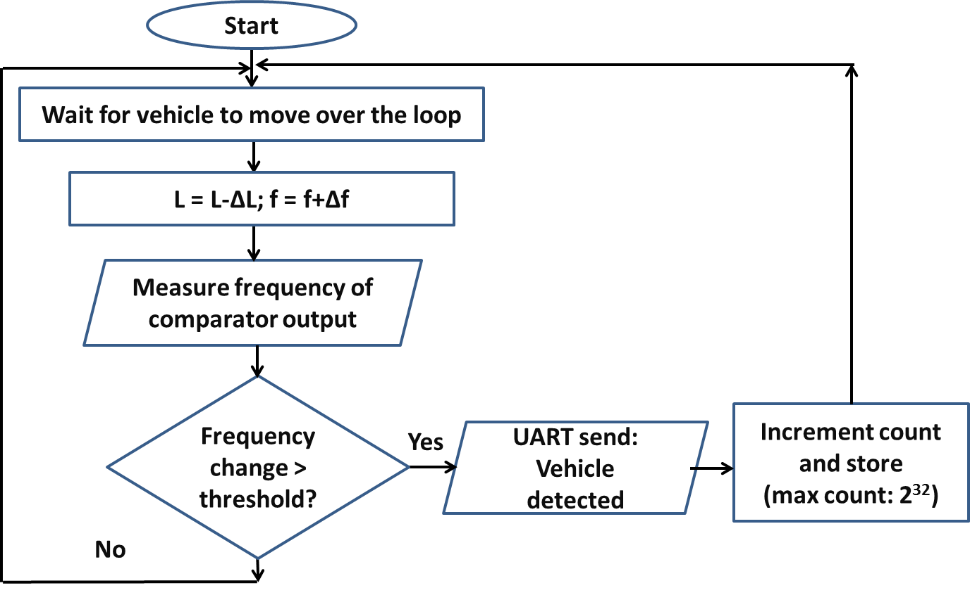

**3.5Design of AMR sensor vehicle detection system**

The AMR sensor vehicle detection system consists of a core module and a vehicle detection module containing magnetic sensors. The iSense Core Module is based on a Jennic JN5148 wireless microcontroller, a chip that combines the controller and the wireless communication transceiver in a single housing. The controller provides 32 bit RISC computation, runs at a software-scalable frequency from 4 to 32 MHz and comprises 128kbytes of memory that are shared by program code and data. The radio part complies with the IEEE 802.15.4 standard. It achieves a data rate of 250kBit/s, provides hardware AES encryption and is ZigBee-ready. It supports distance measurements to neighboring devices using time of flight ranging.

The iSense Vehicle Detection Module (VDM10) is intended for detection of dynamic magnetic fields. The VDM10 is based on the two-axis anisotropic magneto-resistive (AMR) sensor Phillips KMZ52. The module also provides a de-gaussing circuitry and static magnetic field offset compensation. All three are controlled via I2C commands.

An AMR sensor vehicle detection system provides a low power solution for detection of vehicles.

The system consists of two sensor modules which act as slaves and a core module which acts as a master. The slave modules communicate wirelessly with the master module via the Zigbee protocol. The master module is connected to a computer using a serial cable and communicates with it via UART. The computer is used to store the database and display it using a GUI.

The sensors on the slave modules detect the change in the ambient magnetic field. Initially they are calibrated to account for the magnetic field of the ambient environment and the default magnetic field generated by the earth. When a ferromagnetic material (commonly found in vehicles) passes over the sensor it disturbs the magnetic field around it. This change in magnetic field is detected by the sensor. It is observed that the output of the sensor peaks when a vehicle passes over it. These peaks are used to detect the presence of vehicles.

An EWMA (Exponentially weighted moving average) filter is used to eliminate the noise in the sensor output and obtain a smooth waveform. An algorithm running on the slave module that monitors the slope of the waveform when the sensor outputs cross a threshold is used to detect that a vehicle has passed over it. The absence of the slope detection algorithm can cause multiple detections for the same vehicle since the waveform stays over the threshold for several sampling instants. When a vehicle is detected, a time stamp indicating the time at which the vehicle crossed over the sensor is sent to the master module.

The slave modules are buried along the length of the road with a distance of two meters between them. Thus the time stamps sent by the two slave modules differ by a small value Δt as the vehicle passes over the two sensors one after the other. This difference is used to find the speed of the vehicle using the formula

S = D/Δt

Where

S is the speed,

D is the distance between the two sensors

Δt is the time difference

The sensor modules contain an internal clock which is used to keep track of time for which the slave modules are on. The internal clock is started at the moment the sensor modules are turned on. Since both the sensor modules cannot be turned on simultaneously, an initial time difference exists between the clocks of the two sensor modules. This time difference adds to Δt leading to an error in the speed calculation. To eliminate this, the initial time difference is subtracted from Δt. This is achieved using a synchronization algorithm running on the master and slave modules.

When a vehicle is detected, the time difference Δt is calculated by the master module and sent to the PC via UART where the speed is computed and the count and speed are stored in the database.

**3.6 Block diagram for AMR sensor vehicle detection system**

**3.7 Flow chart for the slave module of AMR sensor vehicle detection system**

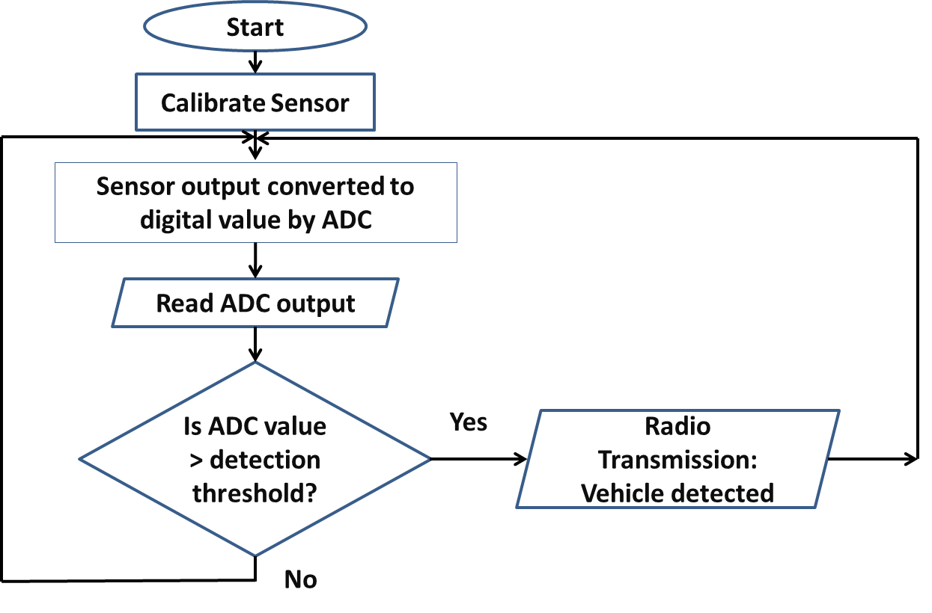

**3.7 Flow chart for the master module of AMR sensor vehicle detection system**

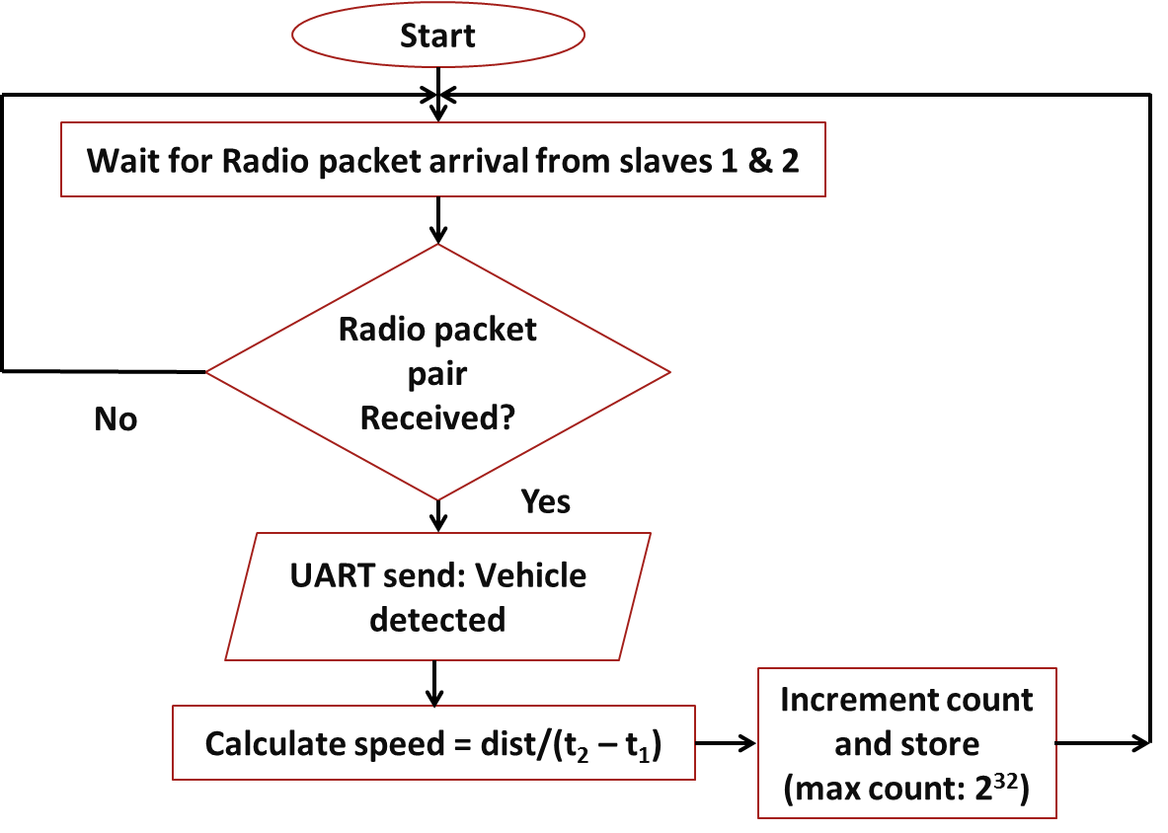

**Market Potential & Competitive advantage:**

The inductive-loop detector is, by far, the most widely used sensor in modern traffic control systems. They provide a simple and low cost solution when detection of vehicles is sufficient.

Video image processing is widely used for vehicle classification. However, this method suffers from disadvantages such as installation and maintenance including periodic lens cleaning. The performance is also affected by inclement weather such as fog, rain, and snow; vehicle shadows, vehicle projection into adjacent lanes, occlusion, day-to-night transition, vehicle/road contrast, and water, salt grime, icicles, and cobwebs on camera lens.

Thus magnetic sensor based classification systems offer an attractive alternative for vehicle classification since it is immune to most of the aforementioned problems.

**Tools**

* **Hardware:**
* iSense Core Module (DS_CM30X)
* iSense Vehicle Detection Module (VDM10)
* induction loops
* Arduino board using ATmega2560 microcontroller
* **Software:**
* Cygwin
* iSense API
* iShell
* Eclipse (C++)
* LT Spice
* Arduino software

**Conclusion**

The proposed traffic detection and classification system provides a low power, low cost solution for traffic monitoring. It can be used to create a dynamic database which can be utilized to promote effective usage of existing roadways and provide an alternative for expensive highway and freeway construction.

**List of publications on which project work is being proposed**

[1]RavneetBajwa, Ram Rajagopal, PravinVaraiya and Robert Kavaler.In-Pavement Wireless Sensor Network for VehicleClassification.

[2] SingYiu Cheung, SinemColeriErgen and PravinVaraiya. Traffic Surveillance with Wireless Magnetic Sensors.

[3] FarshadAhdi, Mehdi KalantariKhandani, MasoudHamedi, Ali Haghani.

Traffic datacollectionandanonymousvehicledetectionusingwirelesssensornetworks.

**References**

[1] Traffic Detector Handbook:Third Edition—Volume I. Publication No. FHWA-HRT-06-108.

[2] S. Y. Cheung, S. Coleri, B. Dundar, S. Ganesh, C.-W.Tan, and P. Varaiya.Traffic measurement and vehicle classification with single magnetic sensor.

Transportation Research Record: Journal of theTransportation Research Board, 1917:173-181, 2006.

[3] L. E. Y. Mimbela and L. A. Klein. A summary ofvehicle detection and surveillance technologies used inintelligent transportation systems.

Technical report,New Mexico State University, 2000.

[4] Honeywell International Inc., “Application Note Vehicle Detection Using AMR Sensors,” available at http://www.magneticsensors.com/datasheets/an218.pdf .

[5] *Traffic Signal Detector Loop Location Design Installation.* IllinoisDepartment of Transportation, District 6, Springfield, IL. 1988.

[6] Courage, K.G., et al. *Inductive Loop Detector Configuration Study—Final Report*, transportation Research Center, prepared byUniversity of Florida. Florida Department of Transportation,Tallahassee, FL. 1985.

[7] Jun Xing, Qi Zeng. A Model Based Vehicle Detection andClassification Using Magnetic Sensor Data. *Department of Signals and Systems,* Chalmers University of Technology, Sweden, 2007.